Speech Analyzer

Version 3.0

Student Manual

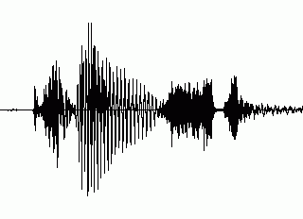

Copyright © 2007 SIL International

Contents
Contents 2
Introduction 3
Module GS: Getting Started 6
Module RS: Recording and Saving Audio Files 16
Module DR: Measuring Duration 23
Module IN: Measuring Intensity 29
Module F0: Measuring Fundamental Frequency 37
Module SG: Measuring Formant Frequencies in a Spectrogram 48
Module SM: Measuring Formant Frequencies in a Spectrum 57
Appendix CU: Cleaning Up Your Computer 65
Appendix ID: Adjusting Settings for Audio Input Devices 67
Index 69

Introduction
Speech Analyzer is a computer program for acoustic analysis of speech sounds.
The goal of this training course is for you to be able to analyze audio data in Speech Analyzer quantitatively with accurate measurements and qualitatively using relevant graphs. In other words, the goal is competent use of Speech Analyzer as an instrument.
This course does not teach everything you can do in Speech Analyzer.
This course does not provide training in acoustic analysis. Training in acoustic phonetics, practice, and experience are essential to make the best use of graphs and measurements in Speech Analyzer. We encourage you to seek the assistance of an experienced linguist in interpreting pitch graphs, spectrograms, and spectra.
For information about acoustic phonetics in general, we recommend that you refer to:
- Baart, Joan. 2001. Acoustic Phonetics. CD-ROM. In LinguaLinks 5.0. Dallas: SIL.
- Johnson, Keith. 2003. Acoustic and Auditory Phonetics, 2nd edition. Cambridge, MA: Blackwell Publishing.
- Ladefoged, Peter. 2001. Vowels and Consonants. Malden, MA: Blackwell Publishing.
- Ladefoged, Peter. 2003. Phonetic data analysis. Malden, Massachusetts and Oxford, England: Blackwell Publishing.

How you will learn
You spend most of your time actually practicing the skills using realistic data—audio files that demonstrate common analysis tasks for field researchers.
Each training module teaches one or more learning objectives. The learning objectives are skills that most people need to be able to do. A brief introduction explains why the skills are important and when to use them. In each module, follow the numbered steps and check your work using the pictures and the tables of expected measurements. For more practice, do the exercises.
If you intend to teach the course or if you are a self-paced learner instead of a student in an instructor-lead course, first read about the course prerequisites and design in the Instructor Guide. Before you start each module in the Student Manual, read the module notes in the Instructor Guide.
To clean up your computer after you have finished the course, see page 65.

How the training course differs from analysis work
In the context of a training course, there are practical reasons for learning skills in a certain order. The way that you apply the skills when you analyze audio data might differ.
In the training course | When you analyze audio data
You will take measurements before you make visual comparisons. | You use quantitative or qualitative methods, or both, in the order that the situation requires.
You will invest most of your time taking measurements because that skill requires more practice to learn than displaying the graphs. | You might invest more time interpreting the graphs—applying knowledge and skill in acoustic phonetics.
You will take enough measurements to learn the skill. | You must take enough measurements to test a hypothesis, using statistical analysis if needed.

Opening course documents
The course includes this Student Manual and an Instructor Guide. To open a document (for example, this Student Manual), do either of the following:
- On the Help menu of Speech Analyzer, point to Training, and then click Student Manual.
- In Windows Explorer, double-click the SA Student Manual.doc file in the following folder*:
C:\Program Files\SIL\Speech Analyzer\Training
*By default, the SIL folder is installed in the Program Files folder on drive C.

Opening and saving audio files
You can open existing audio files (see page 7) or record utterances in Speech Analyzer, and then save them as audio files (see page 16).
The initial default folder in the Open and Save As dialog boxes is the Speech Analyzer folder.
- On Windows 2000 and XP computers, it is in the My Documents folder.
- On Windows Vista computers, it is in the Documents subfolder of your personal folder.
Therefore, each user on a computer initially has a personal folder for audio files.
If you store audio files on the hard disk of a computer for your individual use, we recommend that you organize the files in subfolders of the Speech Analyzer folder.
During the course, make sure to select the correct folder when you save or open a file:
- If you do Module RS, you save audio files in the Speech Analyzer folder. In some exercises of other modules, you open the audio files that you recorded and saved.
- In all of the other modules, you open audio files in the Samples subfolder of the Speech Analyzer folder.

Changes to audio files and folders in Speech Analyzer 3.0
- Speech Analyzer now stores transcription and annotation data in a file with a .saxml extension in the same folder as the audio file.
- When you install Speech Analyzer, sample audio files are installed in the following folder:
C:\Program Files\SIL\Speech Analyzer\Samples
*By default, the SIL folder is installed in the Program Files folder on drive C.
When you start Speech Analyzer the first time, the program creates a Speech Analyzer folder, and then copies the Samples folder into it.
- We recommend that you do not open sample audio files in the Program Files folder.
- We strongly recommend that you do not save audio files in the Program Files folder, especially on computers with Microsoft Windows Vista.

Module GS: Getting Started
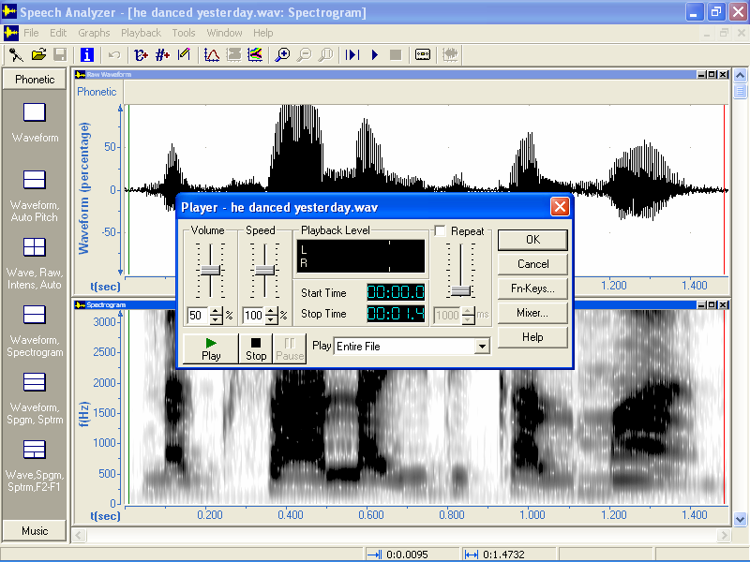
Learning objectives:
- Open an audio file.
- Get information about an audio file.
- Play, stop, pause, and resume playback of a file.
- Mark a point in time or a portion of audio data.
- Zoom in and out to see more or less detail in time-based graphs.
- Play back a portion at different speeds.
- Automatically repeat playback of a portion with a pause.
Audio file: he danced yesterday.wav

In this module, you will learn basic skills in Speech Analyzer. For example, skills you can use when you transcribe phonetic data and learn to say words through mimicry.

Starting Speech Analyzer
      - To start Speech Analyzer, do one of the following:
- On the desktop, double-click the Speech Analyzer icon .
- On the taskbar, click the Start button, click Programs or All Programs, click SIL Software, click Speech Analyzer, and then click Speech Analyzer.
      - If a Speech Analyzer dialog box appears, read the information, and then click OK.
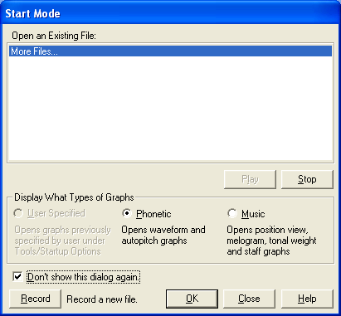
A Speech Analyzer window opens.
      - If the Start Mode dialog box appears:
        - Select the Don’t show this dialog again check box.
        - Click Close.
This dialog box displays a list of recently opened audio files. Because you might not have opened the sample files, you will not use the Start Mode dialog box during the training course.
      - If the Speech Analyzer window does not fill all the available space on the screen, maximize the window.

Opening an audio file
      - On the File menu, click Open.
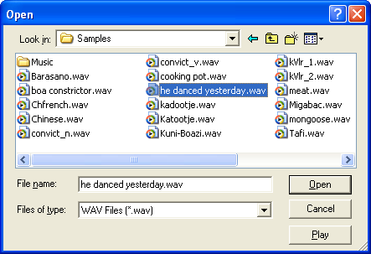
The Open dialog box appears.
      - In the Look in box, navigate to the folder that contains the audio file.
In this case, navigate to Samples folder.
For more information about folders, see page 5.
      - In the list, select the audio file.
In this case, select he danced yesterday.wav.
      - Click Open.
The audio file opens in a window within the Speech Analyzer window. The Raw Waveform graph is in the upper half. The Auto Pitch graph is in the lower half.

Selecting graph types
In Speech Analyzer, a graph is a window that displays a specific type of information about the active audio file. A graph includes the plot area and the horizontal and vertical axes. You can compare patterns that you see in the graphs with sounds that you hear. You can select different graph types for different types of speech analysis.
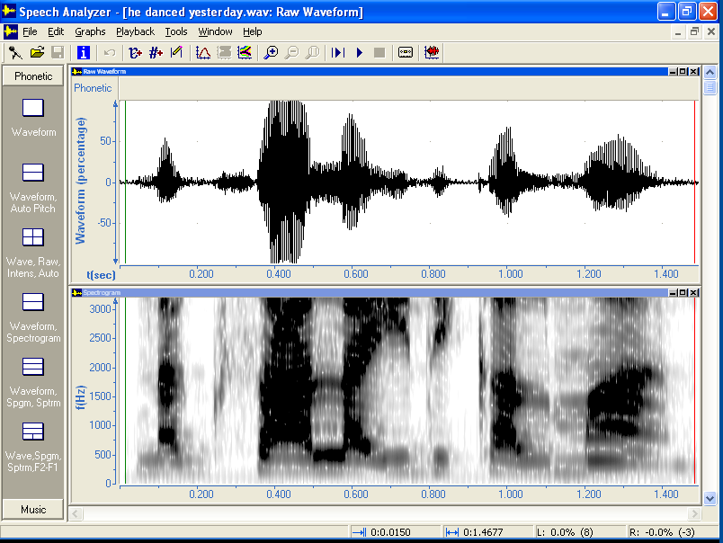
- On the Speech Analyzer taskbar, click Waveform, Spectrogram.
The Raw Waveform graph is in the upper half.

The Spectrogram graph is in the lower half.

What you see on your computer screen might not exactly match the picture in the Student Manual.

Getting information about an audio file
Information about an audio file might be useful to you. Speech Analyzer now stores transcription and annotation data in a file with a .saxml extension in the same folder as the audio file.
      - On the File menu, click Information.
The File Information dialog box appears.
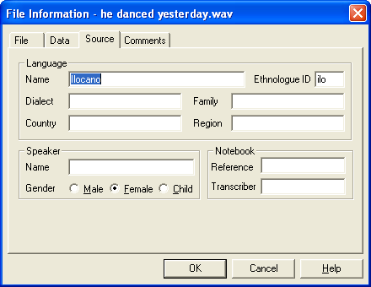

      - Click the Source tab.

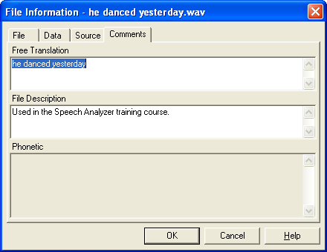

      - Click the Comments tab.

      - Click OK.

Playing an entire audio file
Do one of the following:
- On the toolbar, click the Play File button.
- On the keyboard, press F12.

Stopping the playback of an audio file
In Speech Analyzer, you can stop the playback before the end.
      - On the Playback menu, click Player.
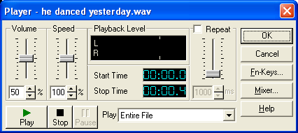
The Player dialog box appears.
      - Find the Stop button at the lower left.
      - Click Play, and after the playback has started,
click Stop.
The audio playback stops.
      - Click Play.
Speech Analyzer plays from the beginning to the end.
      - To close the Player dialog box, click OK.
      - To start and stop playback on the toolbar:
        - Find the Play File and Stop Playing buttons.
        - Click , and then click .
      - To start and stop playback on the keyboard: Press F12, and then press Esc.

Pausing and then resuming the playback of an audio file
In Speech Analyzer, you can pause the playback, and then continue playing.
      - On the toolbar, click the Player button.
The Player dialog box appears.
      - Find the Pause button at the lower left.
      - Click Play.
The Play button becomes steady green.
The Pause button becomes available.
      - Click Play, and after the playback has started, click Pause.
The audio playback stops.
The Play button blinks green.
      - Click Play.
Speech Analyzer plays from the point when you paused to the end.
The Play button becomes steady green.
      - To close the Player dialog box, click OK.

Moving the cursors
When you transcribe an utterance, you might need to break down the utterance into portions.
Speech Analyzer provides a begin cursor and an end cursor to mark portions of audio data in time-based graphs (for example, Raw Waveform and Auto Pitch). The begin cursor is a vertical green line. It marks a point in time and the beginning of a portion. The end cursor is a vertical red line. It marks the end of a portion.
When an audio file opens, the begin cursor is at the left edge and the end cursor is at the right edge of the plot area. Cursors might be difficult to see at the edge of the graph.
If you display an audio file in multiple graphs, moving a cursor in one graph moves it to identical positions in other time-based graphs.
To move the cursors, you can click or drag using the mouse, or press keys on the keyboard.
By default, the cursor snaps to fragments when you click or drag and moves to fragment boundaries when you press arrow keys. In Speech Analyzer, a fragment is the smallest significant unit of audio information in a sound. Fragment boundaries are located at the beginning of large positive pulses, usually pitch pulses. In unvoiced sounds, fragment boundaries are often located at the beginning of major acoustic events like bursts.
Read the information in the following bullet lists, but do not click, drag, or press keys yet.

Moving the begin (green) cursor
- Click at the point where you want the begin cursor to move.
- For more precise movement using the mouse: Drag the green cursor left or right.
- For more precise movement using the keyboard: Hold down the Ctrl key, and then press the Left Arrow or Right Arrow keys.

Moving the end (red) cursor
- Hold down the Shift key, and then click at the point where you the end cursor to move.
- For more precise movement using the mouse: Drag the red cursor left or right.
- For more precise movement using the keyboard: Hold down the Shift key, and then press the Left Arrow or Right Arrow keys.
Now do the following:
      - Using a combination of Ctrl+Right Arrow and Ctrl+Left Arrow, move the begin cursor to 0.0414.
At the lower right, the status bar displays four measurements for the active graph.

The first pane displays the time in minutes and seconds at the begin cursor.
The second pane displays the time difference between the cursors (that is, the duration of the portion of audio data).
The initial values before you move the cursors depend on the screen resolution. Therefore, the values on your computer might not exactly match the preceding picture of the status bar.
      - To move the end cursor one fragment to the left, press Shift+Left Arrow.
Because the duration of the portion decreases, the value in the second pane of the status bar decreases.
      - To move the end cursor to 0.6739 seconds, press Shift+Left Arrow, until the second pane of the taskbar displays 0.6325.
The duration is the difference in time between the cursors: 0.6325 = 0.6739 – 0.0414
      - On the toolbar, click the Play Between Cursors button.
The audio file plays from the begin cursor to the end cursor.
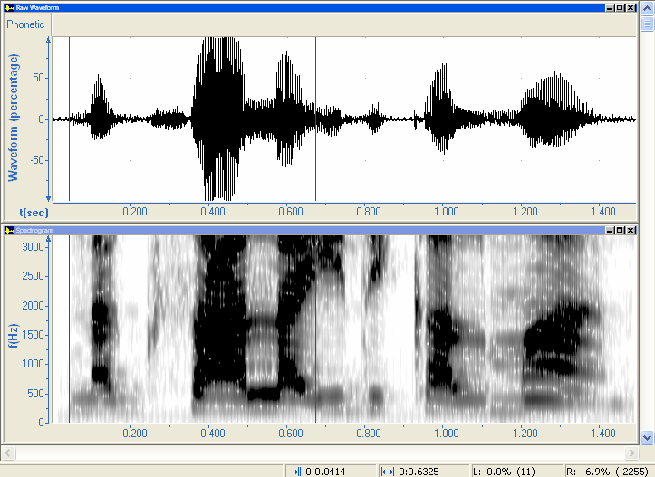

      - To move the begin cursor to about 0.25 seconds, click just above the horizontal axis around 0.25.
      - To move the end cursor to about 0.35 seconds, hold down Shift, and then click just above the horizontal axis around 0.35.
      - To play the portion, press F8.
      - Drag the begin cursor to about 0.05 seconds.
      - Drag the end cursor to about 0.5 seconds.
      - On the toolbar, click the Play Between Cursors button.

Zooming in and out
Sometimes you need to zoom in to see more detail in a time-based graph (for example, to see phonetic segment boundaries).
      - On the toolbar, click the Zoom Step In button three times.
The horizontal scale of the time-based Raw Waveform and Auto Pitch graphs shows more detail.
      - On the toolbar, click the Zoom Step Out button once.
The horizontal scale shows less detail.
      - On the toolbar, click the Zoom Cursors button.
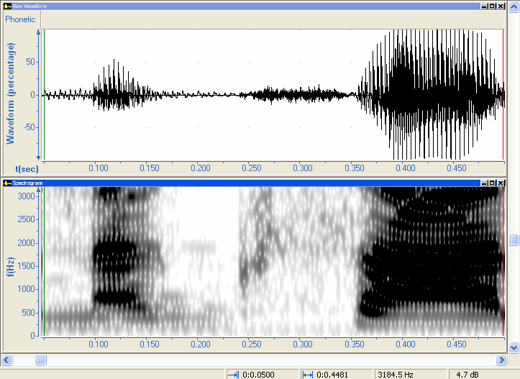
The horizontal scale displays the portion of audio data between the cursors.

      - To see the data after the end cursor, you can drag the scroll box to the right on the horizontal scroll bar at the lower edge of the window.
      - To see the portion of data between the cursors, click the Zoom Cursors button again.
      - On the toolbar, click the Play Between Cursors button.
      - On the Graphs menu, point to View, point to Zoom, and then click Full.
      - For more information: On the Help menu, click Graphs.
The Help window opens.
        - In the first bullet point in Graphs overview, click the graph types hyperlink
        - At the upper left of the table of graph types, click the Raw Waveform hyperlink.
        - Read Raw Waveform graph.
        - Click the Zoom hyperlink, and then read the information.
        - Close the Help window.

Reducing playback speed
To distinguish the phonetic segments, you can set options so Speech Analyzer plays slowly.
      - On the toolbar, click the Player button.
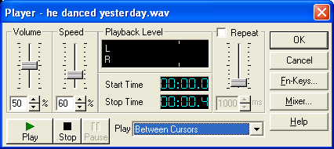
The Player dialog box appears.
      - To see the entire Spectrogram graph, drag the dialog box to the upper half of the window.
      - Set the Speed value to 60%. You can drag the slider. For more precise control, click the arrows or type in the box.
      - If the Play box does not display Between Cursors, click the down arrow, and then select Between Cursors.
      - Click Play.
Speech Analyzer plays the portion at a slower speed.

Repeating playback automatically
Instead of having to click Play repeatedly when you learn to say words through mimicry, you can set options so Speech Analyzer repeats the playback automatically with a delay.
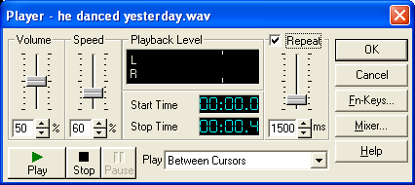
      - In the Player dialog box, select the Repeat check box.
      - To specify the delay, set the Repeat value to 1500 ms
(that is, 1.5 seconds).
      - Click Play.
Speech Analyzer plays the portion repeatedly at the slower speed.
After each repetition of the utterance, practice saying the utterance.
      - Stop the playback. For more information, see page 9.
      - To close the Player dialog box, click OK.

Exercise GS-1
To hear the final part of the utterance, do the following:
      - Move the end cursor to about 1.42 seconds.
      - Move the begin cursor to about 0.675 seconds.
Do the first and second panes of the status bar display the values that you expect?
      - Play the portion back slowly with automatic repetition.

Exercise GS-2
To hear the middle part of the utterance, do the following:
      - Move and the end cursor to about 0.820 seconds.
      - Move the begin cursor to about 0.5 seconds.
Do the first and second panes of the status bar display the values that you expect?
      - Zoom to display the portion of audio data between the cursors.
      - Play the portion back slowly with automatic repetition.
      - Exit Speech Analyzer.

Module RS: Recording and Saving Audio Files
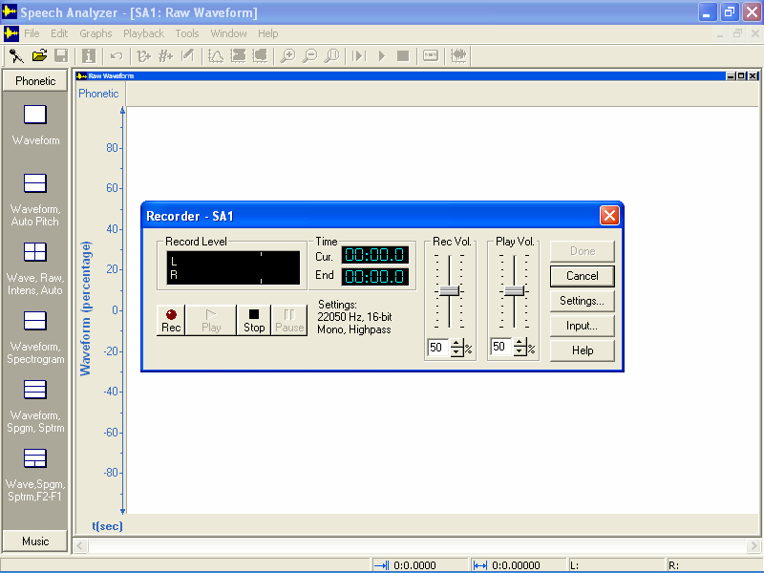
Learning objectives:
- Set the recording level.
- Record an utterance using Speech Analyzer.
- Enter information about an audio file.
- Save an entire recording or a selected portion as a new audio file.
Audio files that you will record and save: color_collar.wav, color.wav, and collar.wav

In Speech Analyzer, you can record data in two ways:
- Record spoken utterances directly from microphone input to the computer.
- Record spoken utterances on an external recording device (for example, a MiniDisc recorder), and then record the playback from line input to the computer.

In this module, you will record data from a microphone. The course assumes that you can make a good recording.

Setting the recording level
      - Make sure that the microphone is connected to the computer.
      - Start Speech Analyzer. For more information, see page 6.
      - On the File menu, click Record New.
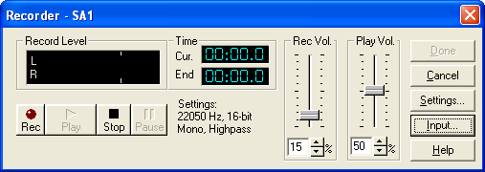
The Recorder dialog box appears.

To adjust the settings of your input device, click Input, and then see page 67.
      - For information about recording audio, click Help.
The Help window opens.
        - Read Record New.
        - Scroll to the beginning of the Help topic, and then click the audio input hyperlink.
        - Read Audio input devices.
        - Minimize the Help window.
      - To test the recording level, speak in a normal voice with your mouth a few inches away from the microphone.
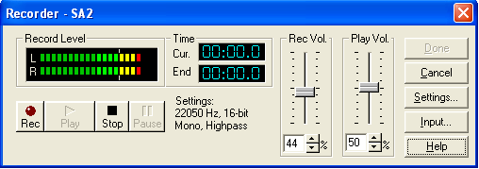
      - Drag the Rec Vol. slider up or down until the bars in the Record Level area stay primarily in the green zone and do not go beyond yellow into the red zone.
      - If you hear feedback while you speak into the microphone:
        - Switch to the Help window.
        - Click the Troubleshooting overview hyperlink, click the Feedback during recording hyperlink, and then read the information.
        - Minimize the Help window.

Recording an utterance
      - When you have finished setting the Rec Vol. level, click Rec.
The Rec button becomes red and Speech Analyzer begins recording.
The Cur box displays the running elapsed time of the recording.
      - Speak the following sentences into the microphone:
The color of the dog is brown. The collar of the dog is brown.
      - Click Stop.
Speech Analyzer stops recording. The End box displays the duration of the recording in minutes and seconds.
      - Click Play.
The recording plays from beginning to end, allowing you to make a judgment of its quality.
      - If the recording is unsatisfactory, repeat steps 1 through 4.
      - When you are satisfied with the recording quality, click Done.
The Recorder dialog box disappears. The Raw Waveform graph appears in the upper half of the Speech Analyzer window and the Auto Pitch graph appears in the lower half.

Verifying the quality of the recording
Before you save a recording as a new audio file, verify that the Raw Waveform graph of the recording appears to be satisfactory. Here are some examples.
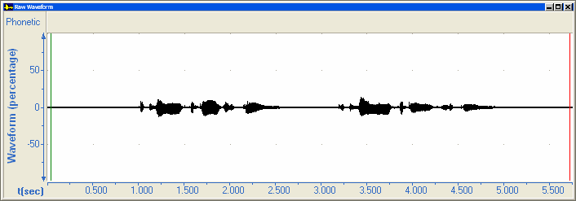
- Unsatisfactory
Recording level is too low:

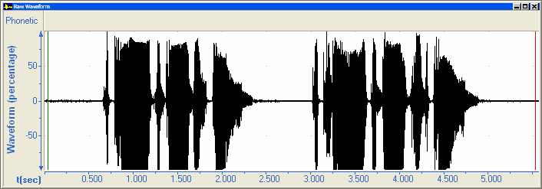
- Unsatisfactory
Recording level is too high:

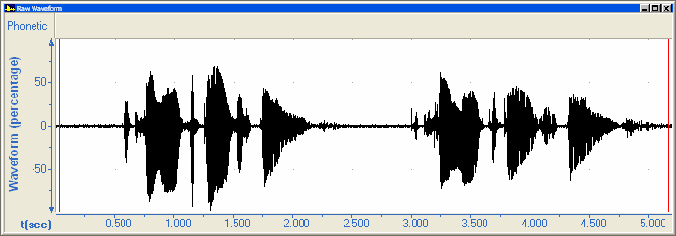
- Satisfactory
Recording level is good:

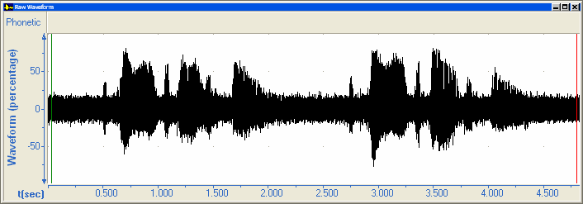
- Unsatisfactory
Recording contains noise:

If you decide that a recording is unsatisfactory, do the following:
      - On the File menu, click Close.
A Speech Analyzer dialog box appears.
      - To confirm that you do not need to save changes, click No.
      - Repeat the preceding procedures starting at step 3 on page 16.

Entering information about an audio file
      - On the File menu, click Information.
The File Information dialog box appears.
      - Click the Source tab.
      - In the Language area, do the following:
- In the Language box, type the name of the language.
In this case, type English.
- In the Ethnologue ID box, type the Ethnologue or ISO-639-3 code that identifies the language, if you know it.
In this case, type eng.
      - In the Speaker area, do the following:
- In the Name box, type the name of the language speaker.
In this case, type your name.
- At the right of Gender, select Male, Female, or Child.
      - Click the Comments tab.
      - In the Free Translation box, you can type the meaning of the utterance in a researcher’s language (for example, English, French, Spanish, or Portuguese).
In this case, type The color of the dog is brown. The collar of the dog is brown.
      - In the File Description box, type Recorded and saved for Module RS of the Speech Analyzer training course.
      - Click OK.

Saving an audio file
In the course, you save audio files in the Speech Analyzer folder. In your work, we recommend that you save the files in subfolders of the Speech Analyzer folder.
      - On the File menu, click Save As.
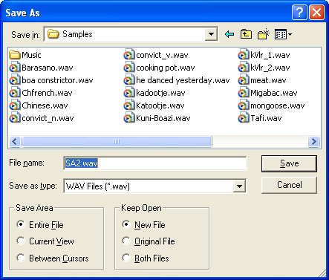
The Save As dialog box appears.
      - Navigate to the folder in which you save new audio files.
In this case, navigate to the Speech Analyzer folder.
If the Save in box displays Samples, click the Up One Level button.
For more information about folders, see page 5.

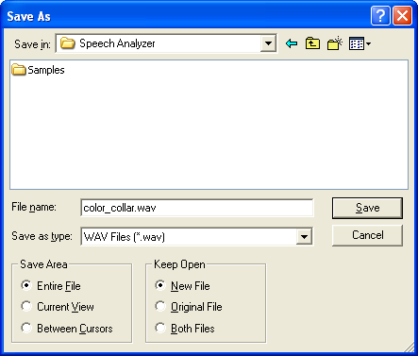

      - In the File Name box, type a file name.
In this case, type color_collar.wav.
      - Click Save.
The Save As dialog box disappears and the file is saved with the specified name.

Saving portions of an audio file
You might record several utterances in one recording session. After the recording session, you can save each utterance as a separate file.
      - On the Speech Analyzer taskbar, click Waveform, Spectrogram.
      - Move the begin (green) cursor to the beginning of the first sentence:
      - Move the end (red) cursor to the end of the first sentence.
      - To make sure that you have marked the first sentence, “The color of the dog is brown,” click the Play Between Cursors button on the toolbar.
      - On the Edit menu, click Select Waveform.
Selecting a portion of an audio file is analogous to selecting text in a word processing program.
      - On the Edit menu, click Copy.
      - On the Edit menu, click Paste as New File.
      - A new file window opens in the Speech Analyzer window. It displays just the portion that you copied.
      - Enter information about the first sentence (for more information, see page 19)
      - On the File menu, click Save As.
The Save As dialog box appears.
      - In the File Name box, type color.wav.
      - Click Save.
The Save As dialog box disappears and the file is saved with the specified name.
      - On the File menu, click Close.
The color.wav window disappears. The color_collar.wav window appears again.
      - Move the begin (green) cursor to the beginning of the second sentence:
      - Move the end (red) cursor to the end of the second sentence.
      - To make sure that you have marked the second sentence, “The collar of the dog is brown,” click the Play Between Cursors button on the toolbar.
      - Repeat steps 5 through 13 to create a collar.wav file.
      - To exit Speech Analyzer: On the File menu, click Exit.

Comparing audio files
You can now compare the two related audio files.
      - Start Speech Analyzer.
      - On the File menu, click Open.
The Open dialog box appears.
      - In the Look in box, navigate to the folder.
In this case, navigate to the Speech Analyzer folder.
      - In the list, select the audio file.
In this case, select color.wav.
      - Click Open.
The audio file opens.
      - On the Speech Analyzer taskbar, click Waveform, Spectrogram.
      - To open the collar.wav file, repeat steps 2 through 6.
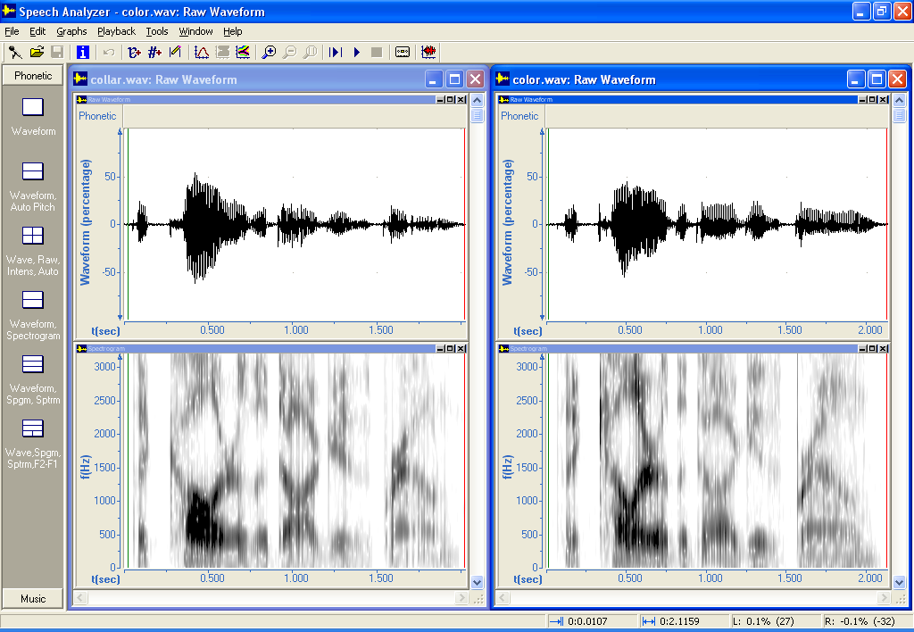
      - On the Window menu,
click Tile Vertical.
Speech Analyzer tiles the collar.wav and the color.wav windows side by side.
Compare the utterances.

      - To make sure the next window you open will be maximized, maximize one of the file windows.
      - Exit Speech Analyzer.

Exercise RS
Record some common greetings in a language you know, and then save each utterance as a separate file.

Important: Make sure to select the correct folder when you open or save a file.
In all of the other modules, you open audio files in the Samples subfolder of the Speech Analyzer folder. In some of the exercises, you open the collar.wav and color.wav files that you saved in the Speech Analyzer folder.

Module DR: Measuring Duration
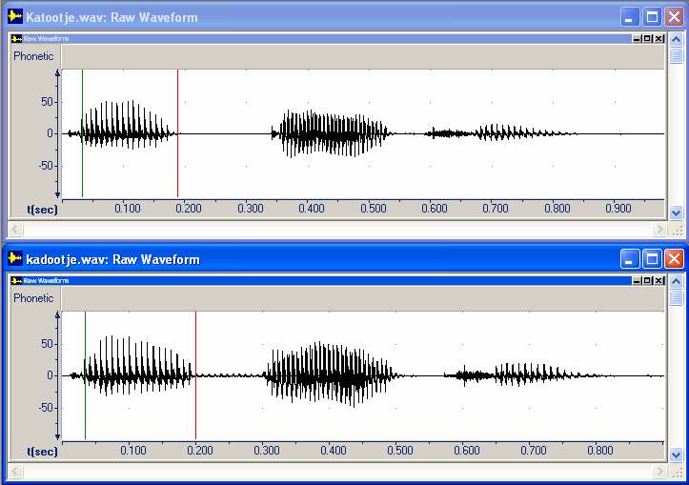
Learning objectives:
- Measure the duration of a portion in a time-based graph.
- Get the length of an audio file.
Audio files: kadootje.wav and Katootje.wav

Measuring duration of events in a speech signal can be useful in any of the following types of linguistic analysis:
- duration of pauses between clauses—discourse studies
- duration of vowels—contrastive vowel length
- time between the release of a plosive and the beginning of voicing (voice onset time)—distinguishing unaspirated, aspirated and voiced stops
- duration of the closure phase—distinguishing voiced and voiceless stops

In this module, you will do a qualitative visual comparison and precise quantitative measurements of duration. For more information about when and how to use duration graphs in linguistic analyses, see chapter 4 of Baart. 2001. Acoustic Phonetics.

Duration measurements
In Module DR, you measure the voiced and voiceless stops [d] and [t] in the Raw Waveform graph. You also get the length of the audio files.
As you do the steps in this module, you will write measurements in the following table.
Round values to three decimal places in the following table.
To verify your measurements when you have finished the module, see page 28.
File | Duration (seconds)
File | stop [d] or [t] | audio file
kadootje.wav
Katootje.wav

Measuring duration of a portion
      - Start Speech Analyzer. For more information, see page 6.
      - Open the kadootje.wav file in the Samples folder. For more information, see page 7.
      - On the toolbar, click the Play File button.
      - Move the begin (green) cursor to the beginning of the closure phase of [d].
See the following picture.
For more information about moving cursors, see page 11.
      - Move the end (red) cursor to the end of the closure phase of [d].
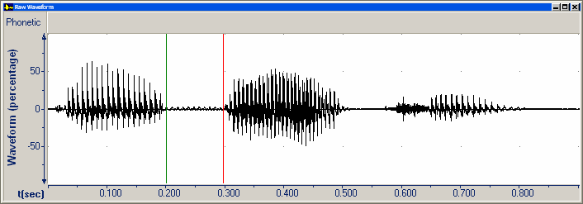

      - Click the title bar of the Raw Waveform graph.
At the lower right, the status bar displays measurements for the active graph.

The first pane displays the time in minutes and seconds at the begin cursor.
The second pane displays the time difference between the cursors (that is, the duration of the portion of audio data).
      - Write the duration measurement in the table on page 23.
      - Open the Katootje.wav file in the Samples folder.
      - Repeat steps 3 through 7 for the closure phase of [t].
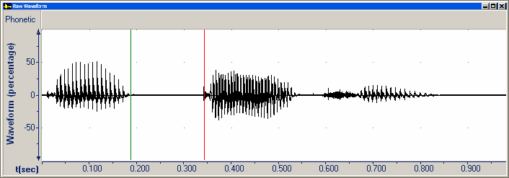

Getting the length of an audio file
      - On the File menu, click Information.
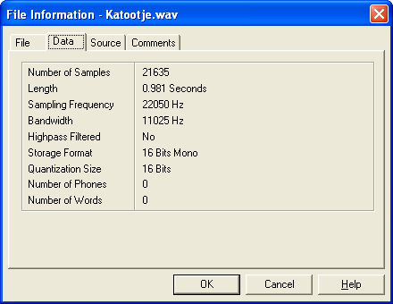
The File Information dialog box appears for the active file.
      - Click the Data tab.
      - Write the length of the active file in the table on page 23.

      - Click Cancel.

      - To switch the active file: On the Window menu, click kadootje.wav.
      - Repeat steps 1 through 4.

Comparing duration
In addition to quantitative comparisons, you can make qualitative comparisons visually.
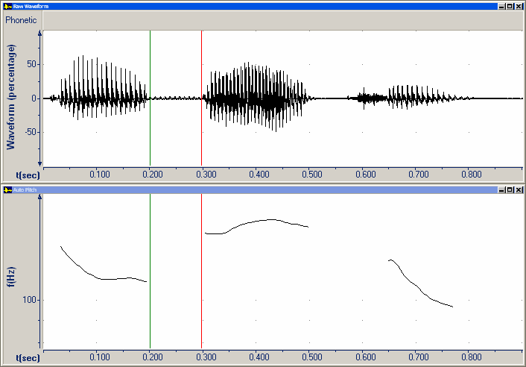
      - To close the Auto Pitch graph in the lower half of the file window, click the Close button.

      - To switch the active file:
On the Window menu,
click Katootje.wav.
      - Close the Auto Pitch graph in the lower half of the file window.

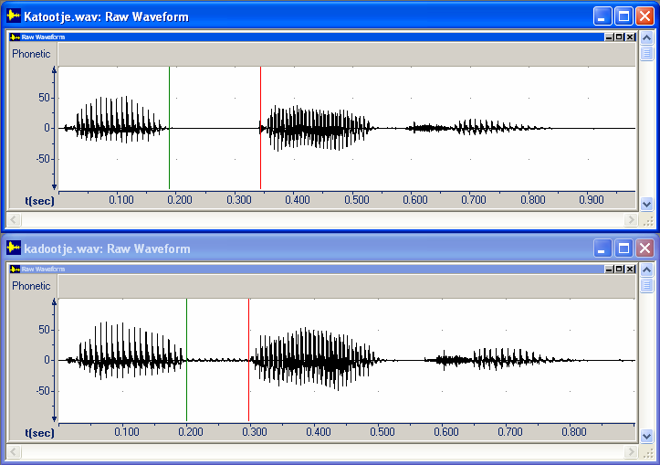
      - On the Window menu,
click Tile Horizontal.
Speech Analyzer displays the active file at the top.
The title bar of the active window and graph has a brighter color. In this case, Katootje.wav is active.
If the title bar of a window or graph is dimmed, it is not active. In this case, kadootje.wav is not active.

      - Notice that the closure phase of [t] has a longer duration than the closure phase of [d].

Exercise DR-1
      - In the kadootje.wav and Katootje.wav files, measure the duration of the vowel [a] preceding the stops [d] and [t].
Write the measurements rounded to three decimal places in the following table.
      - Maximize one of the file windows.
      - Exit Speech Analyzer.

File | Duration
File | vowel [a]
kadootje.wav
Katootje.wav

Exercise DR-2
If you did Module RS, do the following:
      - Start Speech Analyzer.
      - Open the collar.wav and color.wav files in the Speech Analyzer folder.
      - Measure the duration of the vowel in the first syllable of collar and color and the length of the entire audio file. Write the measurements in the following table:
File | Duration (seconds)
File | vowel | audio file
collar.wav
color.wav

      - Exit Speech Analyzer.

Expected duration measurements for Module DR
To check your measurements, compare the table on page 23 with the following data:
File | Duration (seconds)
File | stop [d] or [t] | audio file
kadootje.wav | 0.098 | 0.902
Katootje.wav | 0.150 | 0.981

Expected duration measurements for Exercise DR-1
To check your measurements, compare the table on the preceding page with the following data:
File | Duration
File | vowel [a]
kadootje.wav | 0.166
Katootje.wav | 0.156

Measurements for Exercise DR-2 will vary, because the audio data was recorded by the student.

Module IN: Measuring Intensity
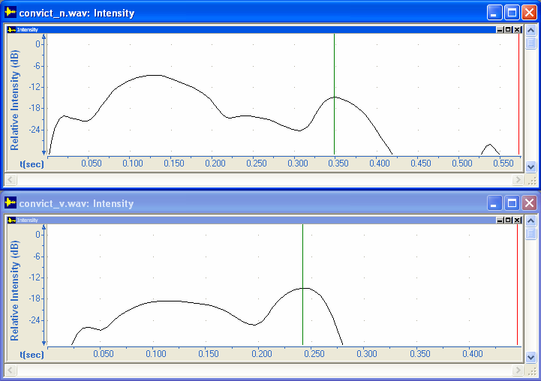
Learning objective: Measure the intensity at a point in an Intensity graph.
Audio files: convict_n.wav and convict_v.wav

Measuring intensity can be useful when analyzing intonation, stress, and accent.
Intensity is the acoustic correlate of (psychoacoustic) loudness. Intensity is not necessarily a direct correlate of stress or accent.

In this module, you will do a qualitative visual comparison and precise quantitative measurements of intensity. For more information about when and how to use intensity graphs in linguistic analyses, see pages 92–104 of Baart. 2001. Acoustic Phonetics.

Intensity measurements
In Module IN, you measure the maximum intensity of syllables in convict as a noun and a verb.
As you do the steps in this module, you will write measurements in the following table.
To verify your measurements when you have finished the module, see page 36.
File | Relative intensity (dB)
File | first syllable | second syllable
convict_n.wav
convict_v.wav

      - Start Speech Analyzer. For more information, see page 6.
      - Open the convict_n.wav file in the Samples folder. For more information, see page 7.

Selecting custom graph types
By default, the Raw Waveform graph is in the upper half of the Speech Analyzer window and the Auto Pitch graph is in the lower half.
You can select sets of graphs that do not appear on the Speech Analyzer taskbar.
      - On the Graphs menu, click Types.
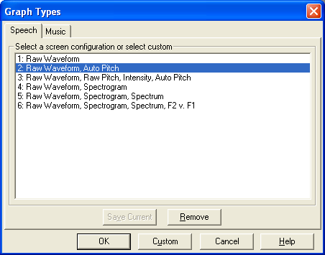
The Graph Types dialog box appears.

      - Click Custom.

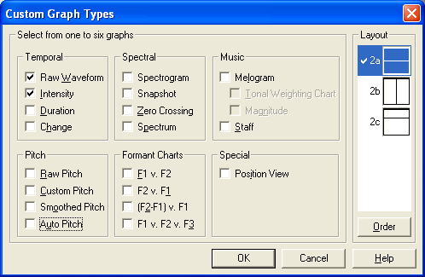
The Custom Graph Types dialog box appears.

      - Select the Intensity check box.

      - Clear the Auto Pitch check box.
      - Click OK.

The Raw Waveform graph remains in the upper half of the Speech Analyzer window.
The Intensity graph replaces the Auto Pitch graph in the lower half.

Changing the display scale
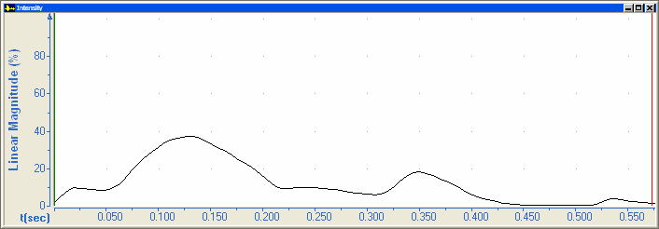
      - Right-click in the plot area of the Intensity graph, and then click Parameters.

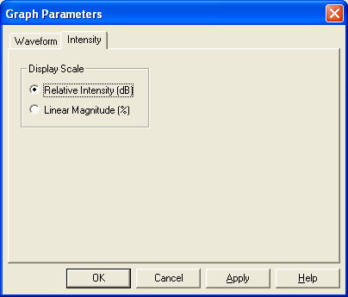
The Graph Parameters dialog box appears with the Intensity tab visible.
      - In the Display Scale area, select Relative Intensity (dB).
      - For more information,
click Help.
The Help window opens.
        - Read Intensity tab, Graph Parameters.
        - If necessary, scroll up, click the Intensity graph hyperlink, and then read the Help topic.
        - Close the Help window.
      - Click OK.
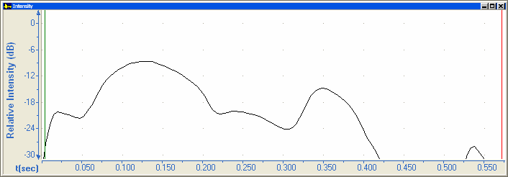
Because relative intensity is a logarithmic scale, the shape of the line changes in the plot area of the Intensity graph.

Measuring intensity
      - Move the begin cursor to the top of the peak in the first syllable at about 0.13 seconds. For more information, see page 11.
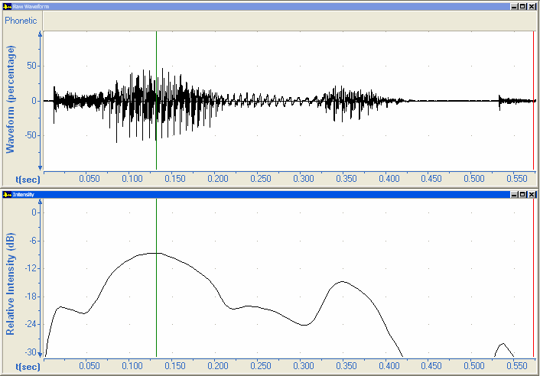

      - Click the title bar of the Intensity graph.
At the lower right, the status bar displays measurements for the active graph.

The third pane of the status bar displays the relative intensity at the begin cursor.
      - Write the relative intensity measurement in the table on page 29.
      - Move the begin cursor to the top of the peak in the second syllable at about 0.34 seconds.
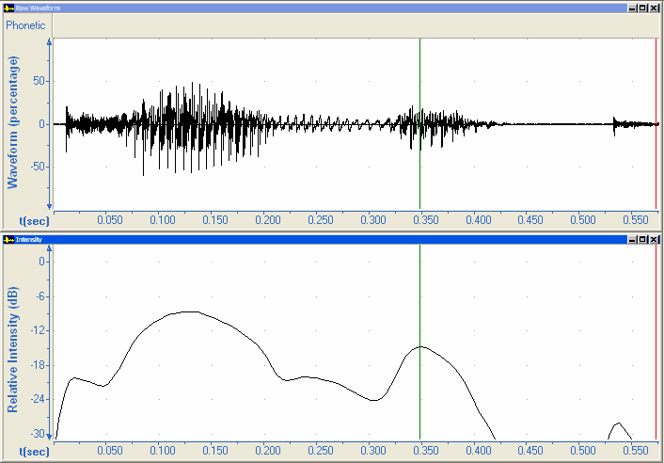

      - Write the relative intensity measurement in the table on page 29.
      - Open the convict_v.wav file in the Samples folder.
      - Select the Raw Waveform and Intensity graphs. For more information, see page 30.
      - Repeat steps 1 through 5.
- The top of the peak in the first syllable is at about 0.11 seconds.
- The top of the peak in the second syllable is at about 0.24 seconds.

Comparing intensity
In addition to quantitative comparisons, you can make qualitative comparisons visually.
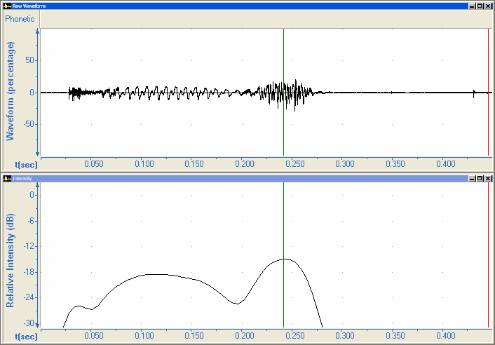
      - To close the Raw Waveform graph in the upper half of the file window, click the Close button.

      - To switch the active file:
On the Window menu,
click convict_n.wav.
      - Close the Raw Waveform graph in the upper half of the file window.

      - On the Window menu,
click Tile Horizontal.
Speech Analyzer displays the active file at the top.
The title bar of the active window and graph has a brighter color. In this case, convict_n.wav is active.
If the title bar of a window or graph is dimmed, it is not active. In this case, convict_v.wav is not active.

      - Notice that the intensity of the first syllable of convict (noun) is greater than convict (verb).
      - To make sure the next window you open will be maximized, maximize one of the file windows.
      - Exit Speech Analyzer.

Exercise IN-1
      - Start Speech Analyzer.
      - Open the kadootje.wav and Katootje.wav files in the Samples folder.
      - Measure the intensity of the first two syllables of each utterance.
File | Relative intensity (dB)
File | first syllable | second syllable
kadootje.wav
Katootje.wav

      - Exit Speech Analyzer.

Exercise IN-2
If you did Module RS, do the following:
      - Start Speech Analyzer.
      - Open the collar.wav and color.wav files in the Speech Analyzer folder.
      - Measure the intensity of the syllables of the words collar and color.
File | Relative intensity (dB)
File | first syllable | second syllable
collar.wav
color.wav

      - Exit Speech Analyzer.

Expected intensity measurements for Module IN
To check your measurements, compare the table on page 29 with the following data:
File | Relative intensity (dB)
File | first syllable | second syllable
convict_n.wav | -8.6 | -14.9
convict_v.wav | -18.5 | -14.9

Expected intensity measurements for Exercise IN-1
To check your measurements, compare the table on the preceding page with the following data:
File | Relative intensity (dB)
File | first syllable | second syllable
kadootje.wav | -12.7 | -7.2
Katootje.wav | -14.0 | -9.6

Measurements for Exercise IN-2 will vary, because the audio data was recorded by the student.

Module F0: Measuring Fundamental Frequency
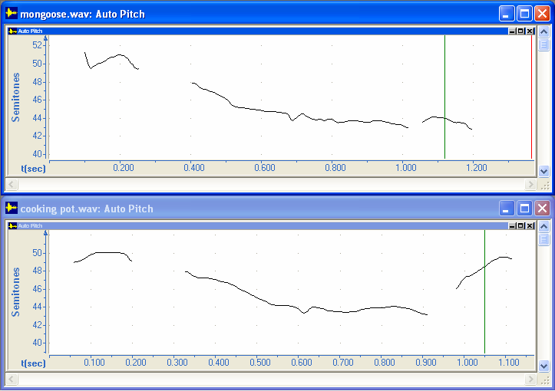
Learning objectives:
- Measure the fundamental frequency in a Pitch graph.
- Copy measurements to a spreadsheet or word processing program.
Audio files: cooking pot.wav and mongoose.wav

Measuring fundamental frequency can be useful when analyzing intonation, tone, and stress.
In Speech Analyzer, the so-called Pitch graphs display fundamental frequency. The fundamental frequency (or f₀) of a periodic signal is the inverse of the period length. The period is the smallest repeating unit of a signal.
Fundamental frequency is the acoustic correlate of (psychoacoustic) pitch. Do not assume the shapes of contours that you see in Speech Analyzer represent pitch and tone as perceived by vernacular language speakers.
Factors that influence the perception of pitch include:
- vowel quality
- adjacent phonetic segments
- the suprasegmental environment—what are the surrounding tones, is there stress, and so on.
- location within a phrase or clause

In this module, you will view pitch contours and take precise measurements of fundamental frequencies at various points in utterance files. For more information about when and how to use pitch graphs in linguistic analyses, see:
- Chapter 5 of Baart. 2001. Acoustic Phonetics.
- Snider, Keith. 1998. Phonetic realisation of downstep in Bimoba, Phonology 15.1, 77-101.
For more information about tone analysis, see:
- Snider, Keith. 1999. The Geometry and Features of Tone. Dallas: The Summer Institute of Linguistics and the University of Texas at Arlington.

Fundamental frequency measurements
In Module F0, you measure the fundamental frequency at the beginning and middle of Ejagham words meaning cooking pot and mongoose recorded in a sentence frame: “here is a _____.”
As you do the steps in this module, you will write measurements in the following table.
Round semitone values to the nearest tenth and hertz values to the nearest whole number.
To verify your measurements when you have finished the module, see page 47.
File | Fundamental frequency (st) |  | Fundamental frequency (Hz)
File | beginning | middle | beginning | middle
cooking pot.wav
mongoose.wav

      - Start Speech Analyzer. For more information, see page 6.
      - Open the cooking pot.wav file in the Samples folder. For more information, see page 7.
      - To hear the tone and compare to the graph, play the file. For more information, see page 9.

Measuring fundamental frequency
      - Move the begin cursor to the beginning of the last word at about 0.98 seconds. For more information, see page 11.
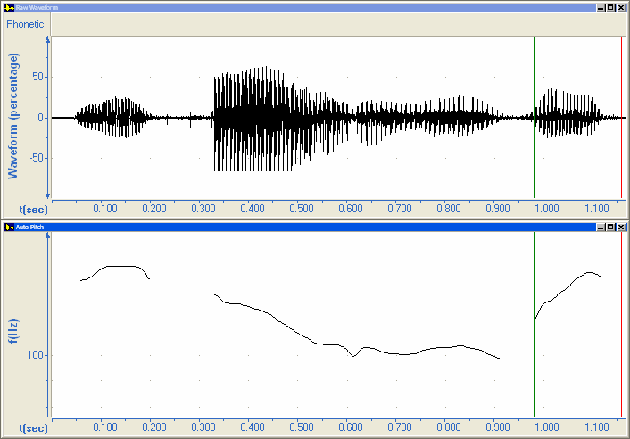

      - Click the title bar of the Auto Pitch graph.
At the lower right, the status bar displays measurements for the active graph.

The third and fourth panes of the status bar display the fundamental frequency at the begin cursor in semitones (st) and hertz (Hz).
      - If the panes do not display frequencies, drag the begin cursor slightly to the right.
      - Write the measurements in the first and third columns of the table on page 38.
      - Move the begin cursor to the middle of the word at about 1.05 seconds.
      - Write the measurements in the second and fourth columns of the table on page 38.
      - Open the mongoose.wav file in the Samples folder.
      - Repeat steps 1 through 6.
- The beginning of the last word is at about 1.06 seconds.
- The middle of the last word is at about 1.12 seconds.

Copying measurements
If there is a spreadsheet or word processing program on the computer, you can copy a set of measurements from Speech Analyzer.
      - On the Edit menu, click Copy Measurements.
Speech Analyzer copies the measurements to the Clipboard in tab-delimited format.
      - To paste the measurements, do one or both of the following:
- Start a spreadsheet program (for example, Microsoft Excel), and then press Ctrl+V.
The first row consists of column headings.
The second row consists of data values.

- Start a word processing program (for example, Microsoft Word), and then press Ctrl+V.
The first paragraph consists of column headings.
The second paragraph consists of data values.
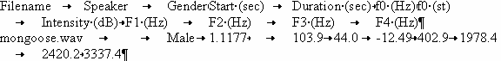

You can delete columns that are not relevant to your task.
      - In the pasted data, find the time value at the begin cursor and the f₀ values in Hz and st.
      - Close the spreadsheet or word processing program.
You do not need to save the changes to the new spreadsheet or document.

Changing the display scale
The status bar displays precise values of the fundamental frequency at the begin cursor. You might also want to quickly estimate approximate values on the vertical axis.
      - In the Auto Pitch graph for the mongoose.wav file, attempt to estimate the frequency at the begin cursor visually using the scale on vertical axis without using the status bar.
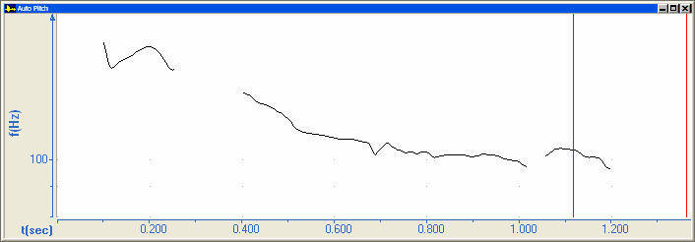

      - Right-click in the plot area of the Pitch graph, and then click Parameters.
The Graph Parameters dialog box appears with the Pitch tab visible.
      - In the Scaling list, select Semitones.
      - Click OK.
A semitone represents a half step on a musical scale. The scale on the vertical axis displays more values.
      - Estimate the frequency at the begin cursor again using the scale on the vertical axis
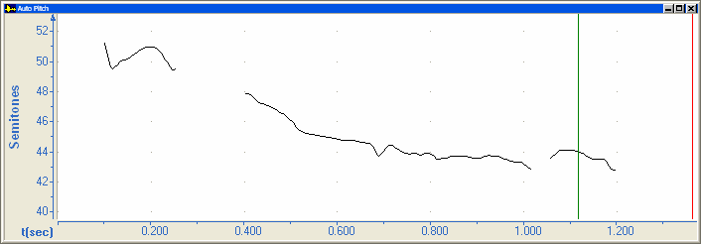

      - To switch the active file: On the Window menu, click cooking pot.wav.
      - Repeat steps 2 through 5.

Comparing fundamental frequency
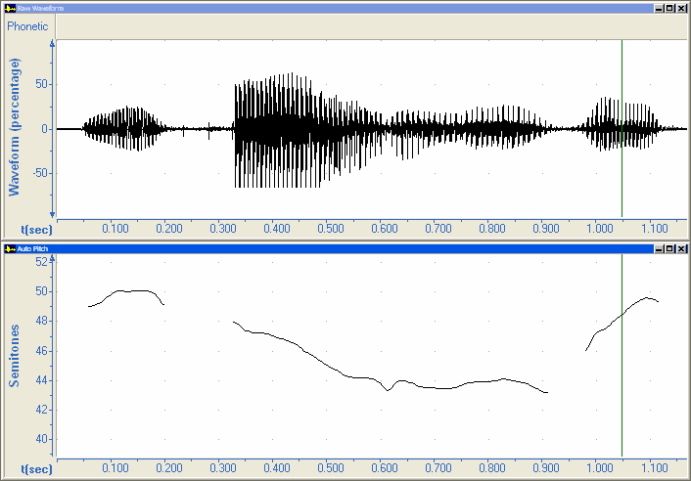
In addition to quantitative comparisons, you can make qualitative comparisons visually.
      - To close the Raw Waveform graph in the upper half of the file window, click the Close button.

      - To switch the active file:
On the Window menu,
click mongoose.wav.
      - Close the Raw Waveform graph in the upper half of the file window.

      - On the Window menu,
click Tile Horizontal.
Speech Analyzer displays the active file at the top.
The title bar of the active window and graph has a brighter color. In this case, mongoose.wav is active.
If the title bar of a window or graph is dimmed, it is not active. In this case, cooking pot.wav is not active.

      - Play the files. For more information, see page 9.
How would you describe the differences in pitch?
      - In the Auto Pitch graphs, notice that the contour of the here is a frame is similar, but the contour of mongoose and cooking pot is different.
The visual appearance of the fundamental frequency contour of cooking pot is rising. Does this mean that there is a rising tone in Ejagham? No—do not assume the shapes of contours that you see in Speech Analyzer represent pitch and tone as perceived by vernacular language speakers.

Selecting graph types and setting graph parameters
The Auto Pitch graph displays continuous lines when the individual data points are close enough. You can use the lines to confirm what you hear. If you hear pitch or tone in an utterance that differs substantially from the computed fundamental frequencies and plotted lines, do not assume the Pitch graph to be correct.
The Auto Pitch graph might not display data where you expect it, due to any of the following:
- background noise
- minimal voicing
- very high or very low fundamental frequency
- rapid change from one frequency to another

To analyze and interpret data, you might need to change the graph type and adjust parameters.
      - For more information: On the Help menu, click Graphs.
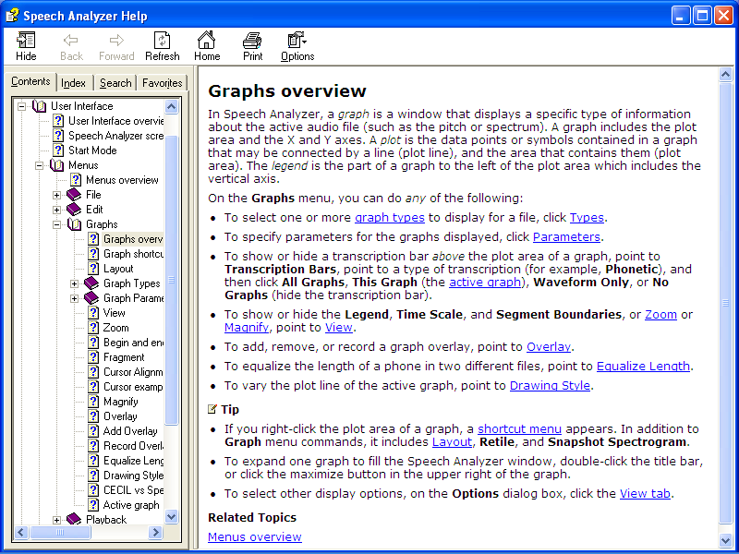
The Help window opens.
        - In the first bullet point in Graphs overview, click the graph types hyperlink
        - At the lower left of the table of graph types, click the Pitch hyperlink.
        - Read Pitch graphs.
        - Click the Auto Pitch graph hyperlink, read the topic, and then click Back on the toolbar.
        - Close the Help window.

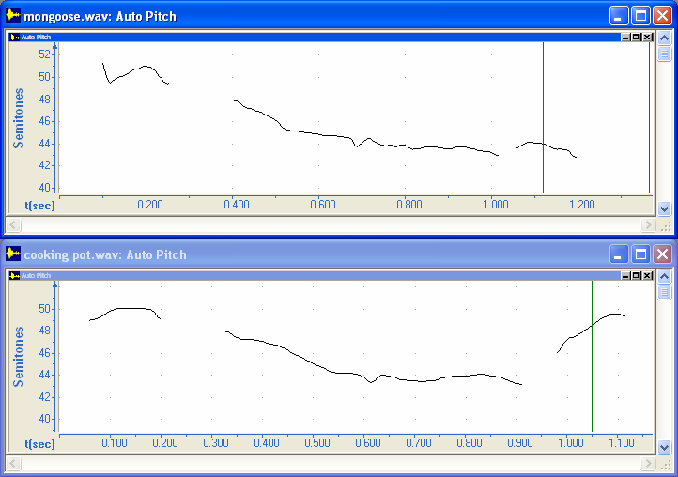
      - To compare Pitch graphs, do the following:
        - Minimize the mongoose.wav window.

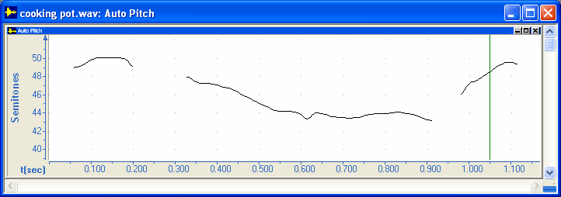
        - Maximize the cooking pot.wav window.

        - On the Graphs menu,
click Types.
The Graph Types dialog box appears.
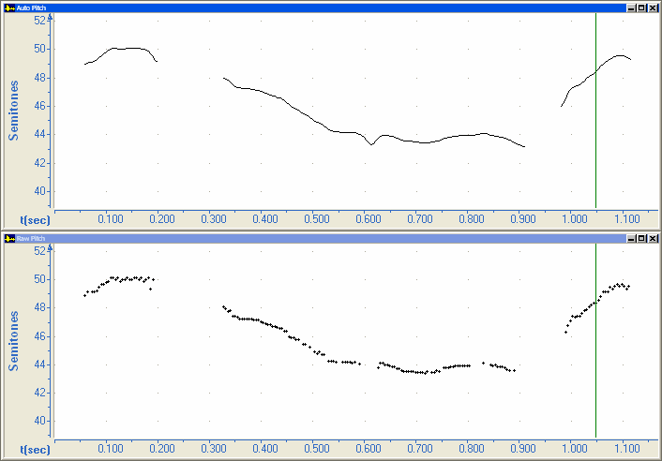
        - Click Custom.
The Custom Graph Types dialog box appears.
        - Select the Raw Pitch check box.
        - Click OK.
The Auto Pitch graph is in the upper half of the window.
The Raw Pitch graph is in the lower half.

Compare the line in the upper half to the data points in the lower half.
Speech Analyzer extrapolated data from the available points in at least three places.
In this case, the extrapolated data is in the frame, not the word for cooking pot.
      - To see additional data points that Speech Analyzer filtered out, do the following:
        - Right-click in the plot area of the Raw Pitch graph, and then click Parameters.
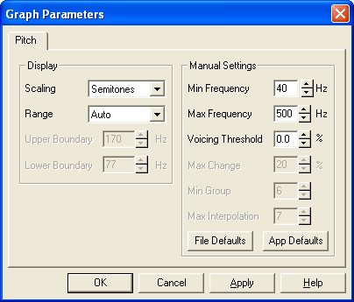
The Graph Parameters dialog box appears with the Pitch tab visible.
        - For more information,
click Help.
The Help window opens.
        - Read Pitch tab, Graph Parameters.
        - Close the Help window.
        - In the Graph Parameters dialog box, change the value in the Voicing Threshold box to 0.0%.

        - Click OK.

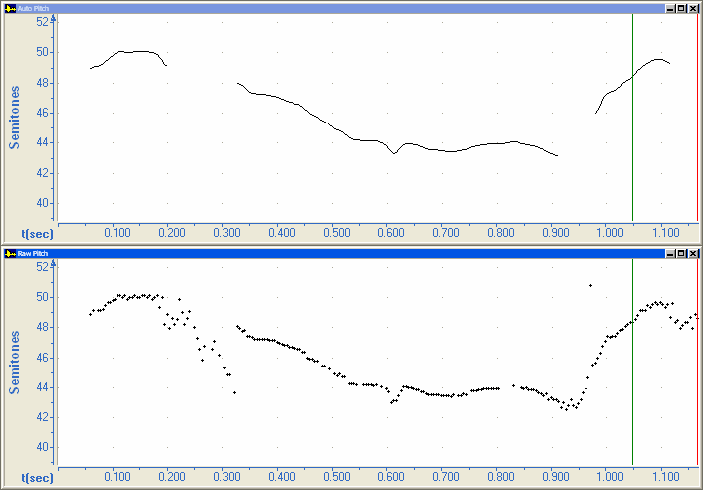

In this case, the additional points are suspect, because they appear where there is minimal voicing.

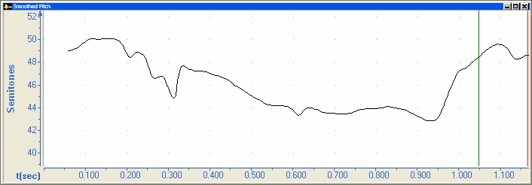
      - To see a smoothed line corresponding to these parameters, right-click in the plot area of the Raw Pitch graph, point to Types, and then click Smoothed Pitch.

      - To change the display scale back to the default, do the following:
        - Right-click in the plot area of the Auto Pitch graph, and then click Parameters.
The Graph Parameters dialog box appears with the Pitch tab visible.
        - In the Scaling list, select Logarithmic.
        - Click OK.
      - Exit Speech Analyzer.
      - If a Speech Analyzer dialog box appears, click No. You do not need to save the change to the voicing threshold for the cooking pot.wav file.

Exercise F0-1
      - Start Speech Analyzer.
      - Open the Chinese.wav file in the Samples folder.
      - Measure the fundamental frequency at the beginning and end of the first and fifth occurrence of the vowel [a].
- Measure the first [a] at 0.1888 and 0.2291 seconds.
- Measure the fifth [a] at 1.4818 and 1.5960 seconds.
Round semitone values to the nearest tenth and hertz values to the nearest whole number.
Write the four sets of measurements in the following table:
Vowel | Fundamental frequency (st) |  | Fundamental frequency (Hz)
Vowel | beginning | end | beginning | end
first [a]
fifth [a]

      - Exit Speech Analyzer.

Exercise F0-2
If you did Module RS, do the following:
      - Start Speech Analyzer.
      - Open the collar.wav and color.wav files in the Speech Analyzer folder.
      - Measure the fundamental frequency in the two syllables of collar and color.
Round semitone values to the nearest tenth and hertz values to the nearest whole number.
File | Fundamental frequency (st) |  | Fundamental frequency (Hz)
File | first syllable | second syllable | first syllable | second syllable
collar.wav
color.wav

      - Exit Speech Analyzer.

Expected fundamental frequency measurements for Module F0
To check your measurements, compare the table on page 38 with the following data:
File | Fundamental frequency (st) |  | Fundamental frequency (Hz)
File | beginning | middle | beginning | middle
cooking pot.wav | 46.0 | 48.5 | 117 | 134
mongoose.wav | 43.4 | 44.0 | 101 | 104

Expected fundamental frequency measurements for Exercise F0-1
To check your measurements, compare the table on the preceding page with the following data:
Vowel | Fundamental frequency (st) |  | Fundamental frequency (Hz)
Vowel | beginning | end | beginning | end
first [a] | 60.6 | 60.7 | 271 | 272
fifth [a] | 60.9 | 55.2 | 276 | 198

Measurements for Exercise F0-2 will vary, because the audio data was recorded by the student.

Module SG: Measuring Formant Frequencies in a Spectrogram
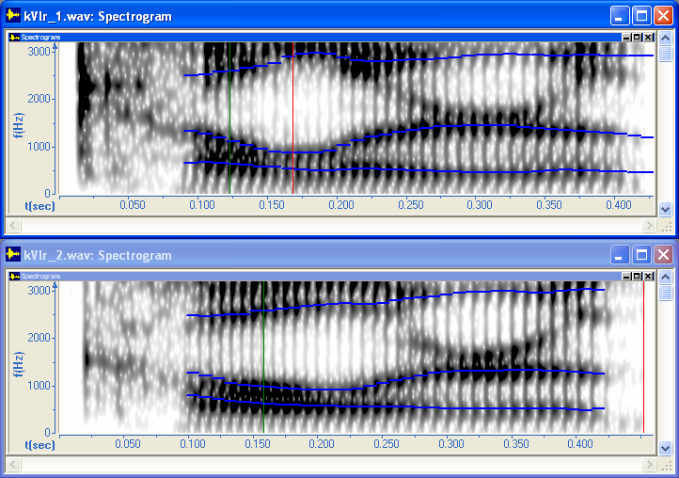
Learning objective: Measure formant frequencies in a Spectrogram graph.
Audio files: kVlr_1.wav and kVlr_2.wav

A spectrogram is a three-dimensional plot of the intensity of the frequency content of a signal as it changes over time. Usually the vertical axis indicates frequency, the horizontal axis indicates time, and the color or gray scale indicates intensity.
You can use a spectrogram to measure formants, especially vowel formants. Formants (or formant frequencies) are the resonant frequencies of the vocal tract. Individual formants are numbered in order of ascending frequency (as in F1, F2, F3, and so on). Formants appear as dark bands in a spectrogram.
You can also use a spectrogram to analyze voiced and unvoiced sounds, periodic and aperiodic sounds, glottal pulses, and fundamental frequency overtones.

In this module, you will do a qualitative visual comparison between spectrograms, along with displaying and measuring formants frequencies. For more information about interpreting spectrograms for linguistic analyses, see chapter 3 of Baart. 2001. Acoustic Phonetics.

Formant frequency measurements
In Module SG, you measure formant frequencies of vowels in two similar utterances to determine if there is any significant difference.
To minimize context effects on the vowels, both words were originally recorded in a frame.
As you do the steps in this module, you will write measurements in the following table.
Round the values to the nearest whole number.
To verify your measurements when you have finished the module, see page 56.
File | Formant frequencies of vowel
File | F1 | F2 | F3
kVlr_1.wav
kVlr_2.wav

Selecting graph types
      - Start Speech Analyzer. For more information, see page 6.
      - Open the kVlr_1.wav file in the Samples folder. For more information, see page 7.
The Raw Waveform graph is in the upper half of the Speech Analyzer window.
The Auto Pitch graph is in the lower half.
      - On the Speech Analyzer taskbar, click Waveform, Spectrogram.
The Spectrogram graph replaces the Auto Pitch graph in the lower half.
      - Play the file. For more information, see page 9.
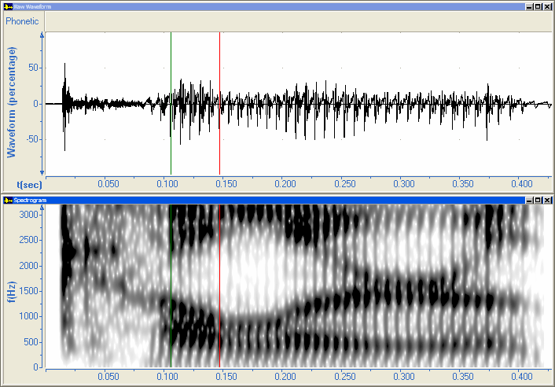
      - Move the begin cursor to the beginning of the vowel just past 0.10 seconds. For more information, see page 11.
[k]
V
[l]
      - Move the end cursor to the end of the vowel at about 0.15 seconds.
      - Notice the visual changes in intensity and shape of the formants in the vowel as it transitions from the preceding consonant [k] to the following consonant [l].

Identifying and measuring formant frequencies visually
In the Spectrogram graph, identify the formants of the vowel between the cursors. The formant slope shows that the vowel is in transition from the [k] to the [l].
      - Click the title bar of the Spectrogram graph.
      - Point at the lowest formant band (F1) in the area between the begin and end cursors.
When you move the mouse pointer into the plot area of a Spectrogram graph, it becomes a pointing hand .
At the lower right, the status bar displays measurements for the active graph.

The first pane displays the time at the begin cursor.
The second pane displays the time difference between the cursors (that is, the duration of the portion of audio data).
The third pane displays the frequency at the mouse pointer. It corresponds to the scale on the vertical axis.
The fourth pane displays the intensity for the frequency at the mouse pointer.
      - Write the measurement of the F1 frequency in the following table.
File | Formant frequencies of vowel
File | F1 | F2 | F3
kVlr_1.wav

      - Point at the second formant band (F2) in the area between the begin and end cursors.
      - Write the measurement of the F2 frequency in the table.
      - Point at the third formant band (F3) in the area between the begin and end cursors.
      - Write the measurement of the F3 frequency in the table.
      - For more information: On the Help menu, click Graphs.
The Help window opens.
        - In the first bullet point in Graphs overview, click the graph types hyperlink
        - In the table of graph types, click the Spectrogram hyperlink.
        - Read Spectrogram graph.
        - Close the Help window.

Displaying formant tracks
Speech Analyzer can compute and display formant tracks (lines) representing the center frequency of each formant at each point in time.
You can use the formant tracks to confirm what you identify visually. If you identify formants in a spectrogram that differ substantially from the computed formant tracks, do not assume the formant tracks to be correct.
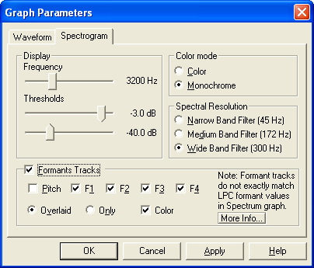
      - Move the begin cursor to the middle of the first vowel at 0.1225 seconds.
      - Right-click in the plot area of the Spectrogram graph, and then click Parameters.
The Graph Parameters dialog box appears with the Spectrogram tab visible.
      - Select the Formant Tracks check box.

      - Click OK.
The default color of formant tracks is blue.
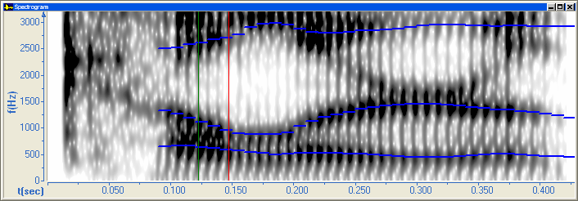

At the lower right, the status bar displays measurements for the active graph.

The four panes display the values of F1, F2, F3, and F4 at the begin cursor. That is, the frequencies at the intersection of the begin cursor and the formant tracks.

Measuring formant frequencies
When the Spectrogram graph displays formant tracks, the values in the status bar depend on the begin cursor, not the mouse pointer.
      - Write the measurements of F1, F2, and F3 in the table on page 48.
      - Open the kVlr_2.wav file in the Samples folder.
      - On the Speech Analyzer taskbar, click Waveform, Spectrogram.
      - Move the begin cursor to the middle of the vowel at 0.1576 seconds.
      - Click the title bar of the Spectrogram graph.
If you do not see the measurements that you expect in the status bar, make sure that the correct file window and graph is active.
      - Write the measurements of F1, F2, and F3 in the table on page 48.

Changing display parameters
      - Right-click in the plot area of the Spectrogram graph, and then click Parameters.
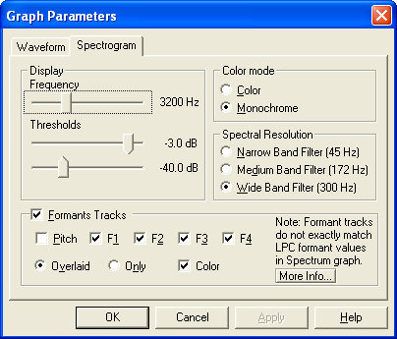
The Graph Parameters dialog box appears with the Spectrogram tab visible.
      - To see the entire Spectrogram graph, drag the dialog box to the upper half of the window.
      - In some cases, the Threshold sliders can help you see formants more clearly. As you do the following, observe the effect on the formants in the Spectrogram graph.
- Drag the upper Threshold slider all the way to the left, and then to the right.
- Drag the lower Threshold slider all the way to the left,
and then to the right.
      - For more information, click Help.
The Help window opens.
        - Read Spectrogram tab, Graph Parameters.
        - Click the formant hyperlink. Read the topic.
        - Close the Help window.
      - To reset the parameters, do the following in the Display area:
- Drag the upper Threshold slider until -3.0 dB appears again.
- Drag the lower Threshold slider until -40.0 dB appears again.
      - Click Cancel.

Comparing spectrograms
In addition to quantitative comparisons, you can make qualitative comparisons visually.
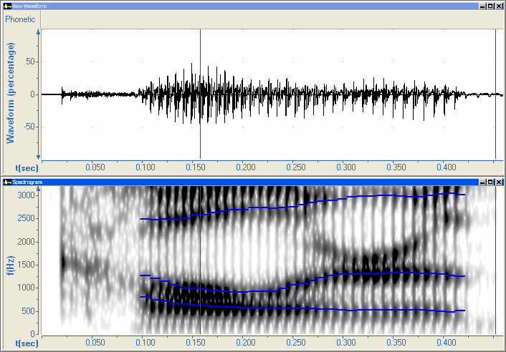
      - To close the Raw Waveform graph in the upper half of the file window, click the Close button.

      - To switch the active file:
On the Window menu,
click kVlr_1.wav.
      - Close the Raw Waveform graph in the upper half of the file window.

      - On the Window menu,
click Tile Horizontal.
Speech Analyzer displays the active file in the upper half.
The title bar of the active window and graph has a brighter color. In this case, kVlr_1.wav is active.
If the title bar of a window or graph is dimmed, it is not active. In this case, kVlr_2.wav is not active.

      - Play the files. For more information, see page 9.
How would you describe the differences in the utterances?
      - In the Spectrogram graphs, compare the shape of the formants. In the table on page 48, compare the formant measurements.
What similarities and differences do you notice between the two spectrograms?
      - To make sure the next window you open will be maximized, maximize one of the file windows.
      - Exit Speech Analyzer.

Exercise SG-1
      - Start Speech Analyzer.
      - Open the boa constrictor.wav and meat.wav files in the Speech Analyzer folder.
      - Measure formant frequencies of the first vowel.
- In the boa constrictor.wav file, measure at 0.1343 seconds.
- In the meat.wav file, measure at 0.1544 seconds.
File | Formant frequencies of vowel
File | F1 | F2 | F3
boa
constrictor.wav
meat.wav

      - Exit Speech Analyzer.

Exercise SG-2
If you did Module RS, do the following:
      - Start Speech Analyzer.
      - Open the collar.wav and color.wav files in the Speech Analyzer folder.
      - Measure formant frequencies of the vowels in the words collar and color.
File | Formant frequencies of vowel
File | F1 | F2 | F3
collar.wav
color.wav

      - Exit Speech Analyzer.

Expected formant frequency measurements for Module SG
To check your measurements, compare the table on page 48 with the following data:
File | Formant frequencies of vowel
File | F1 | F2 | F3
kVlr_1.wav | 638 | 1116 | 2613
kVlr_2.wav | 616 | 968 | 2589

Expected formant frequency measurements for Exercise SG-1
To check your measurements, compare the table on the preceding page with the following data:
File | Formant frequencies of vowel
File | F1 | F2 | F3
boa constrictor.wav | 452 | 891 | 2209
meat.wav | 458 | 1620 | 2245

Measurements for Exercise SG-2 will vary, because the audio data was recorded by the student.

Module SM: Measuring Formant Frequencies in a Spectrum
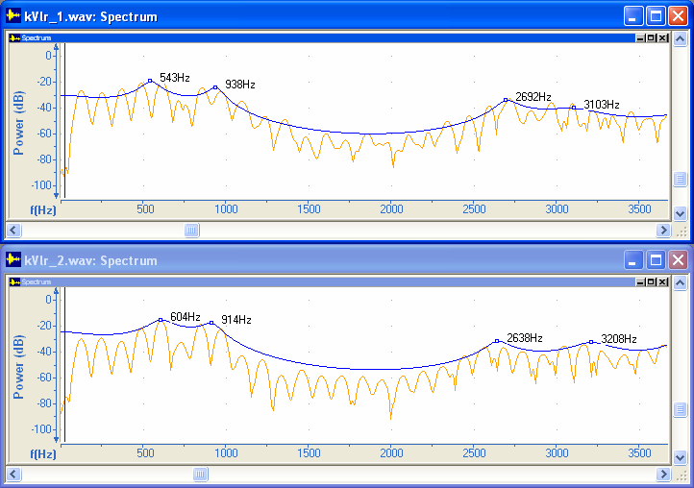
Learning objective: Measure formant frequencies in a Spectrum graph.
Audio files: kVlr_1.wav and kVlr_2.wav

A spectrum is a two-dimensional plot of the intensity of the frequency content of a signal.
In a spectrum, the horizontal axis indicates frequency and the vertical axis indicates intensity. In a spectrogram, the horizontal axis indicates time, the vertical axis indicates frequency, and the color or gray scale indicates intensity. You can think of a spectrum as a slice of a spectrogram at a point in time. The peaks and valleys in a spectrum correspond to the darker and lighter gray scale in a spectrogram.
In Speech Analyzer, the Spectrum graph displays the energy levels at each frequency in the portion of audio data between the begin and end cursors.
A spectrum can be useful when determining whether or not two similar sounds are the same or different by comparing formant frequencies. Formants (or formant frequencies) are the resonant frequencies of the vocal tract. The term is also used to refer to the peaks in the spectrum caused by these resonances. Individual formants are numbered in order of ascending frequency (as in F1, F2, F3, and so on).

Spectra, as compared to spectrograms, provide a view that is more conducive to taking precise measurements of formant frequencies.
For more information about knowing when to use a spectrum or spectrogram, and how to interpret these graphs, see chapter 3 of Baart. 2001. Acoustic Phonetics.

Formant frequency measurements
In Module SM, you measure formant frequencies of vowels in two similar utterances, and then compare the measurements to Module SG.
To minimize context effects on the vowels, both words were originally recorded in a frame.
As you do the steps in this module, you will write measurements in the following table.
To verify your measurements when you have finished the module, see page 64.
File | Formant frequencies of vowel
File | F1 | F2 | F3
kVlr_1.wav
kVlr_2.wav

      - Start Speech Analyzer. For more information, see page 6.
      - Open the kVlr_1.wav file in the Samples folder. For more information, see page 7.

Selecting graph types
      - On the Speech Analyzer taskbar, click Waveform, Spgm, Sptrm.
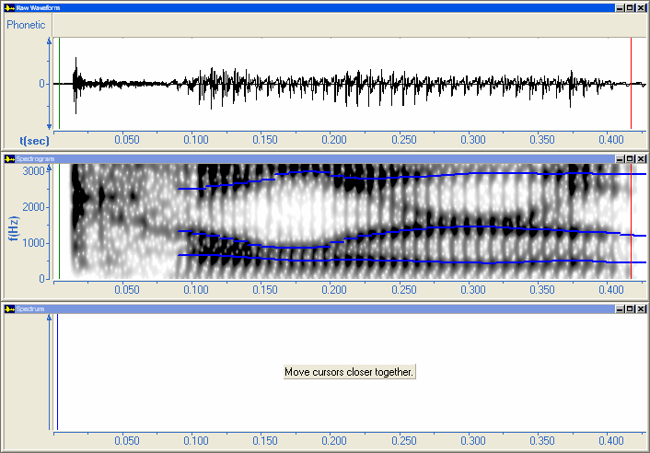
The Raw Waveform is in the upper third of the Speech Analyzer window.
The Spectrogram graph is in the middle third.
The Spectrum graph is in the lower third.
The plot area of the Spectrum graph displays Move cursors closer together. Do not do it now.

      - For more information: On the Help menu, click Graphs.
The Help window opens.
        - In the first bullet point in Graphs overview, click the graph types hyperlink
        - In the table of graph types, click the Spectrum hyperlink.
        - Read Spectrum graph.
        - Close the Help window.

Measuring formant frequencies
      - Move the begin cursor to about 0.095 seconds.
      - Move the end cursor to about 0.155 seconds.
      - On the toolbar, click Zoom Cursors.
The horizontal scale of the time-based Raw Waveform and Spectrogram graphs displays the portion of audio data.
      - To move the begin cursor into the vowel, press Ctrl+Right Arrow a few times until 0.1143 appears in the first pane of the status bar.
      - To move the end cursor, press Shift+Left Arrow a few times until 0.0244 appears in the second pane of the status bar.
The portion of audio data consists of three fragments of the vowel.
In Speech Analyzer, a fragment is the smallest significant unit of audio information in a sound. Fragment boundaries are located at the beginning of large positive pulses, usually pitch pulses. In unvoiced sounds, fragment boundaries are often located at the beginning of major acoustic events like bursts.
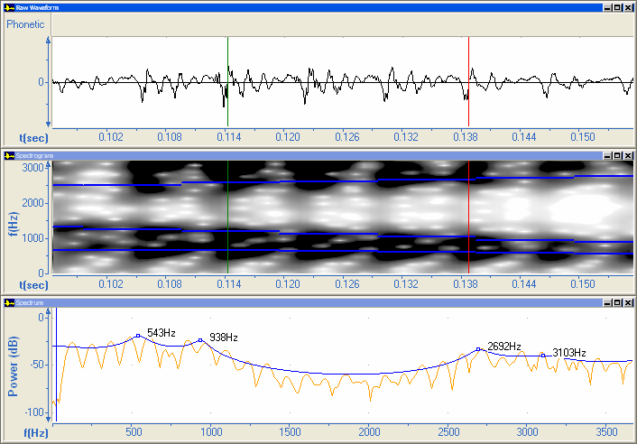

The Spectrum graph displays the spectrum for the portion of audio data between the begin and end cursors. Speech Analyzer computes F1, F2, F3, and F4 using an LPC model.
      - Write the measurements of F1, F2, and F3 in the table on page 58.
      - Open the kVlr_2.wav file in the Samples folder.
      - On the Speech Analyzer taskbar, click Waveform, Spgm, Sptrm.
      - Move the begin cursor to about 0.098 seconds.
      - Move the end cursor to about 0.2 seconds.
      - On the toolbar, click Zoom Cursors.
The horizontal scale of the time-based Raw Waveform and Spectrogram graphs displays the portion of audio data.
      - To be able to make smaller adjustments to the cursors, do the following:
        - On the Tools menu, click Options.
The Options dialog box appears.
        - In the Cursor area, click Zero Crossing
A zero crossing is a point where an audio waveform crosses the zero-line from negative to positive.
In this case, you need to override the end of the fragment that Speech Analyzer identifies.
        - Click OK.
      - To move the begin cursor into the vowel press Ctrl+Right Arrow several times until 0.1414 appears in the first pane of the status bar.
      - To move the end cursor, press Shift+Left Arrow several times until 0.0244 appears in the second pane of the status bar.
The portion of audio data consists of three fragments of the vowel.
      - Write the measurements of F1, F2, and F3 in the table on page 58.
      - To compare F1, F2, and F3, click the title bar of the Spectrogram graph.
The four panes display the values of F1, F2, F3, and F4 at the begin cursor. That is, the frequencies at the intersection of the begin cursor and the formant tracks.
If you do not see the measurements that you expect in the status bar, make sure that the correct file window and graph is active.
      - Compare the measurements in the tables on pages 48 and 58.
Speech Analyzer computes formant values on Spectrogram and Spectrum graphs in slightly different ways.

Comparing spectra
In addition to quantitative comparisons, you can make qualitative comparisons visually.
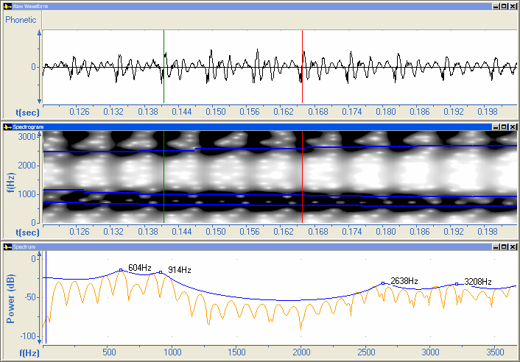
      - To close the Raw Waveform and Spectrogram graphs, click the Close buttons.

      - To switch the active file:
On the Window menu,
click kVlr_1.wav.
      - Close the Raw Waveform and Spectrogram graphs

      - On the Window menu,
click Tile Horizontal.
Speech Analyzer displays the active file in the upper half.
The title bar of the active window and graph has a brighter color. In this case, kVlr_1.wav is active.
If the title bar of a window or graph is dimmed, it is not active. In this case, kVlr_2.wav is not active.

      - In the Spectrum graphs, compare the shapes of the lines.
What similarities and differences do you notice in the vowels?
For example, note that F1 and F2 are farther apart in kVlr_1.wav than in kVlr_2.wav.
      - To make sure the next window you open will be maximized, maximize one of the file windows.
      - Exit Speech Analyzer.

Exercise SM-1
      - Start Speech Analyzer.
      - Open the boa constrictor wav and meat.wav files in the Speech Analyzer folder.
      - Measure formant frequencies of the first vowel.
- In the boa constrictor.wav file, move the begin and end cursor to about 0.10 and 0.20 seconds, click Zoom Cursors, and then move the cursors until 0.1343 and 0.0200 appear in the first and second pane of the status bar.
- In the meat.wav file, move the begin and end cursor to about 0.10 and 0.20 seconds, click Zoom Cursors, and then move the cursors until 0.1544 and 0.0228 appear in the first and second pane of the status bar.
File | Formant frequencies of vowel
File | F1 | F2 | F3
boa
constrictor.wav
meat.wav

      - Exit Speech Analyzer.

Exercise SM-2
If you did Module RS, do the following:
      - Start Speech Analyzer.
      - Open the collar.wav and color.wav files in the Speech Analyzer folder.
      - Measure formant frequencies of the vowels of the words collar and color.
File | Formant frequencies of vowel
File | F1 | F2 | F3
collar.wav
color.wav

      - Exit Speech Analyzer.

Expected formant frequency measurements for Module SM
To check your measurements, compare the table on page 58 with the following data:
File | Formant frequencies of vowel
File | F1 | F2 | F3
kVlr_1.wav | 543 | 938 | 2692
kVlr_2.wav | 604 | 914 | 2638

Expected formant frequency measurements for Exercise SM-1
To check your measurements, compare the table on the preceding page with the following data:
File | Formant frequencies of vowel
File | F1 | F2 | F3
boa constrictor.wav | 411 | 892 | 2223
meat.wav | 478 | 1640 | 2843

Measurements for Exercise SM-2 will vary, because the audio data was recorded by the student.

Appendix CU: Cleaning Up Your Computer
The procedures in some modules of the training course included resetting options that you changed. After you have finished the course, do any of the following to clean up your computer.

Module GS
The Start Mode dialog box displays a list of recently opened audio files. During the course, you did not use the Start Mode dialog box (see page 6). To use it in your work, do the following:
      - On the File menu, click Open Startup.
The Start Mode dialog box appears.
      - Do any of the following:
- Select an existing file, and then click OK.
- Click Record.
- Click Close.

Module RS
If you did Module RS, you saved a recording and two selected portions (see page 20).
      - In Windows Explorer, navigate to the Speech Analyzer folder.
      - Delete the collar.wav, color.wav, and color_collar.wav files.
      - If you did Exercise RS, delete any other audio files that you saved (see page 22).

Module IN
      - Right-click in the plot area of an Intensity graph, and then click Parameters.
The Graph Parameters dialog box appears with the Intensity tab visible.
      - In the Display Scale area, select Linear Magnitude (%).
      - Click OK.

Module SG and SM
      - Right-click in the plot area of a Spectrogram graph, and then click Parameters.
The Graph Parameters dialog box appears with the Spectrogram tab visible.
      - Clear the Formant Tracks check box.
      - Click OK.

Module SM
      - On the Tools menu, click Options.
The Options dialog box appears.
      - In the Cursor area, click Fragment.
      - Click OK.

Appendix ID: Adjusting Settings for Audio Input Devices
The following procedures are for a microphone. The settings for other audio input devices are similar. The procedure for Microsoft Windows Vista is on the next page.
For more information about setting the recording level, see page 16.

Windows XP
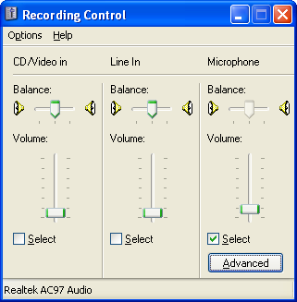
      - In the Recording Control dialog box: If you are using a microphone, make sure that its check box is selected.
      - On the Options menu, do one of the following:
- If there is already a check mark at the left of Advanced Controls, press Esc.
- Otherwise, click Advanced Controls.
      - Under Microphone, click Advanced.
Depending on the sound capabilities of your computer, an Advanced Controls for Microphone dialog box or other similar dialog box appears.
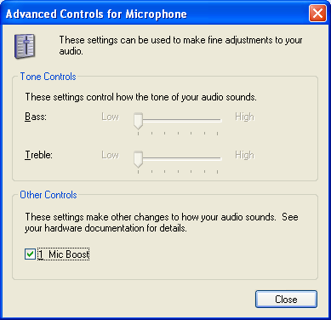
      - Select the Mic Boost, MIC Boost, or Microphone gain control check box.
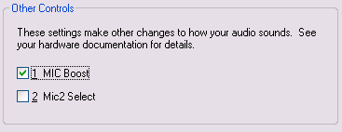

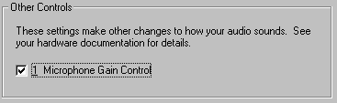

      - Close the Advanced Controls for Microphone and Recording Control dialog boxes.
The Recorder dialog box reappears.
To continue the procedure to set the recording level, see page 17.

Windows Vista
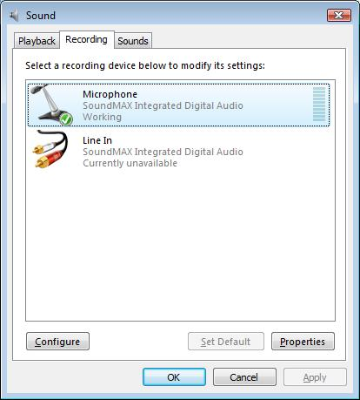
      - If you are using a microphone, make sure it is listed. If it is not listed, do the following:
        - Right-click in the list, and then click Show Disabled Devices.
        - Right-click the microphone item, and then click Enable.
      - Double-click Microphone.

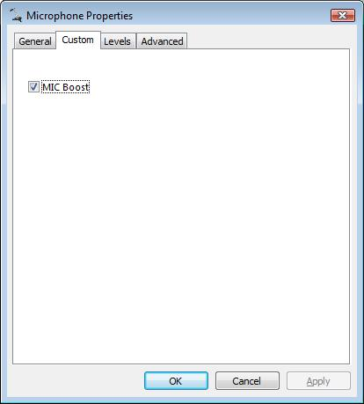
The Microphone Properties dialog box appears.
      - Click the Custom tab.
      - Select the MIC Boost check box.

      - Click OK.

      - To close the Sound dialog box, click OK.
The Recorder dialog box reappears.
To continue the procedure to set the recording level, see page 17.

Index

accent, 29
acoustic phonetics, 3
active graph, 26, 34, 42, 54, 62
audio files
closing, 21
comparing, 22, 26, 34, 42, 54, 62
deleting, 65
length, 25
opening, 5, 7
playing, 9
portions, 11, 21
saving, 5, 20, 21
Auto Pitch graph, 39
Baart, Joan, 3, 23, 29, 37, 48, 57
background noise, 18, 43
begin cursor, 11
cleaning up your computer, 65
closing
audio files, 21
graphs, 26, 34, 42, 54, 62
comparing audio files, 22, 26, 34, 42, 54, 62
copying
audio data, 21
measurements, 40
course documents, 4
cursors, 11
custom graph types, 30, 44
decibels (dB), 31
deleting audio files, 65
desktop, 6
display scale, 13, 31, 41, 60
Documents folder, 5
duration, 23
end cursor, 11
exiting Speech Analyzer, 21
files
audio. See audio files
information, 8, 19, 25
saxml, 5
formants, 48, 51, 57
fragments, 11, 60, 66
fundamental frequency, 37
graphs, 7
closing, 26, 34, 42, 54, 62
parameters, 31, 41, 45, 51, 53, 65, 66
types, 7, 30, 44, 49, 59
hertz (Hz), 39
horizontal axis, 13, 60
information about files, 8, 19, 25
intensity, 29
intonation, 29, 37
Johnson, Keith, 3
Ladefoged, Peter, 3
length of audio files, 25
loudness, 29
marking points in time, 11
measuring
duration, 23
formant frequencies, 48, 58
fundamental frequency, 37
intensity, 29
microphone settings, 67
minimal voicing, 43
mouse pointer, 50
moving the cursors, 11
My Documents folder, 5
noise, 18, 43
opening
audio files, 5, 7
course documents, 4
options, 61, 66
parameters, 31, 41, 45, 51, 53, 65, 66
pasting
audio data, 21
measurements, 40
pausing the playback, 10
period, 37
personal folder, 5
phonetics, 3
pitch, 37
playing audio files, 9
pausing, 10
reducing speed, 14
repeating, 14
stopping, 9
pointer, 50
portions of audio files, 11, 21
Raw Pitch graph, 44
recording utterances, 17
reducing playback speed, 14
relative intensity (dB), 31
repeating playback, 14
saving audio files, 5, 20, 21
saxml files, 5
selecting
graph types, 7, 30, 44
portions of audio files, 21
selecting graph types, 49, 59
semitones (st), 39, 41
slowed replay, 14
Smoothed Pitch graph, 45
Snider, Keith, 37
spectrogram, 48
spectrum, 57
speed of playback, 14
spreadsheets, 40
starting Speech Analyzer, 6
status bar, 12, 24, 32, 39, 50, 51
stopping the playback, 9
stress, 29, 37
taskbar, 6, 7
tiling graphs, 22, 26, 34, 42, 54, 62
tone, 37
vertical axis, 31, 41
voicing, 43, 45
volume of recording, 17
word processors, 40
zero crossings, 61
zooming, 13, 60

